CS 255 Project One: Business Requirements Document

System Components and Design

Purpose
• The purpose of this project is to design a web-based system for DriverPass that helps customers prepare for DMV driving tests through online learning, practice testing, and on-the-road training.
• The client is DriverPass, owned by Liam, with Ian serving as the IT officer responsible for maintaining and modifying the system.
• The system will support customers, the secretary, management, drivers, and the IT officer while keeping the company’s training, scheduling, and customer information organized.

System Background
• DriverPass was created to address the need for better driver training because many students fail their DMV driving tests after relying mainly on previous test questions.
• DriverPass wants one system that supports online classes and practice tests, two-hour driving lesson reservations, customer registration, training packages, driver notes, reports, and communication with customers.
• Customers must be able to schedule, cancel, and modify appointments online, while the secretary must be able to schedule appointments for customers who call or visit the office.
• The system must track the customer, assigned driver, vehicle, date, and time for each driving lesson. DriverPass currently has 10 cars, with a driver assigned to each car.
• The system must support three training packages: six hours of driving; eight hours plus an in-person DMV rules lesson; and twelve hours plus the in-person lesson, online class content, and practice tests.
• DriverPass wants a web-based, preferably cloud-hosted system so data can be accessed from computers and mobile devices and backup/security responsibilities can be handled by the hosting environment.

Objectives and Goals
• Provide secure, role-based access for the owner, IT officer, secretary, customers, and other authorized employees.
• Allow customers and the secretary to create, modify, and cancel two-hour driving lesson reservations.
• Track who created, canceled, or last modified each reservation and provide printable activity reports.
• Match each driving lesson with the correct customer, driver, vehicle, date, and time.
• Support the three current training packages and allow an authorized user to disable a package so new customers cannot register for it.
• Provide online classes, practice tests, and progress information including test name, time taken, score, and status.
• Record lesson times and driver comments and make them available to authorized users.
• Receive notifications when the DMV provides updated rules, policies, or sample questions.
• Allow reports and selected information to be downloaded for offline work, such as use in Excel.

Requirements

Nonfunctional Requirements

Performance Requirements
• The system will operate as a web-based application, preferably hosted in the cloud, and will be available from computers and mobile devices with an internet connection.
• Online changes will be written to the central system so DriverPass does not create duplicate or conflicting copies of data.
• DMV rules, policies, and sample questions will be updated when new information is received from the DMV connection, and DriverPass will receive a notification of the update.
• The interview does not define a specific response-time target, so measurable response-time requirements should be confirmed during detailed design and testing.

Platform Constraints
• The user-facing system will run through a web browser rather than depend on one desktop operating system.
• The system should support access from both computers and mobile devices.
• The back end will require centralized data storage for customer accounts, reservations, packages, test results, lesson records, and audit history.
• DriverPass prefers a cloud-hosted solution because the company does not want to manage its own backup and security infrastructure.
• Offline access is limited to downloaded reports or information; records cannot be modified offline.

Accuracy and Precision
• Each user will be identified by an individual account and assigned permissions based on role.
• Reservation records will identify who created, canceled, or last modified the reservation so changes can be traced accurately.
• Each lesson record will identify the customer, driver, vehicle, date, start time, and end time.
• Test progress will accurately identify the test name, time taken, score, and status as not taken, in progress, failed, or passed.
• Customer registration will capture the required contact, payment, pickup, and drop-off information; the pickup and drop-off locations are expected to be the same.
• The interview does not specify whether usernames or other inputs are case-sensitive, so that rule should be defined consistently during detailed interface design.

Adaptability
• Authorized staff will be able to maintain user accounts and change access without changing application code.
• The IT officer will have full account access to reset passwords, block former employees, and maintain or modify the system.
• The current release will allow an authorized user to disable a training package so new registrations cannot be made for it.
• Adding, removing, or fully customizing package modules is identified as a future enhancement that would require developer or systems analyst support.
• A web/cloud design will allow the application to be maintained centrally as browsers, devices, and hosted services are updated.

Security
• Users will authenticate through individual accounts, and access will be limited according to their assigned roles and rights.
• The IT officer will be able to reset accounts and block access when an employee leaves the company.
• Customers who forget their passwords will be able to use an automatic password-reset process.
• Customer registration includes sensitive payment information, so data exchanges and stored account information must be protected by the cloud-hosted security controls selected for the system.
• Audit information will be retained for reservation creation, cancellation, and modification so DriverPass can identify who performed an action.
• The interview does not specify a failed-login or brute-force lockout threshold; that security rule should be defined before implementation.

Functional Requirements
• The system shall allow customers to register and maintain an online account.
• The system shall allow customers to automatically reset a forgotten password.
• The system shall allow customers to create, modify, and cancel driving lesson appointments online.
• The system shall allow the secretary to create appointments for customers who call or visit the office.
• The system shall schedule driving lessons in two-hour sessions and associate each lesson with a customer, driver, vehicle, date, and time.
• The system shall support the three current DriverPass training packages and prevent new registrations for a package that has been disabled.
• The system shall provide online course content and practice tests to customers enrolled in the applicable package.
• The system shall display online test progress including test name, time taken, score, and status.
• The system shall store driver comments and lesson start and end times.
• The system shall capture customer information including name, address, phone number, state, payment information, and pickup/drop-off location.
• The system shall track who created, canceled, or last modified a reservation.
• The system shall generate printable activity reports and allow selected reports or information to be downloaded.
• The system shall receive DMV updates for rules, policies, and sample questions and notify DriverPass when an update is available.
• The system shall allow the IT officer to reset accounts, block access, and perform authorized system maintenance.

User Interface
• The interface will be web-based and accessible from standard computers and mobile devices.
• Customers will use the interface to manage appointments, access training materials and practice tests, review test progress, and reset passwords.
• The secretary will use an input form to enter customer information and create appointments for customers who contact the office.
• The owner and authorized staff will be able to review customer information, lesson information, driver notes, reservation activity, and reports according to their permissions.
• The IT officer will have administrative access for account maintenance and system changes.
• The customer information page will include identifying/contact information, online test progress, driver notes, lesson times, and other relevant student information.
• The system will include a contact page and a way for DriverPass to contact the student.

Assumptions
• Users will have reliable internet access when creating or changing system records because updates cannot be performed offline.
• Customers and employees will use current web browsers on computers or mobile devices capable of accessing the cloud-hosted application.
• DriverPass will provide or approve the content used for online classes, practice tests, DMV rules, and policies.
• DriverPass will maintain accurate employee role assignments so permissions can be applied correctly.
• The current fleet consists of 10 cars with assigned drivers, as stated in the interview, and the initial scheduling design will support that operating model.

Limitations
• Users cannot modify or update DriverPass records while offline; offline work is limited to downloaded reports or information.
• The initial release will not allow nondevelopers to add or remove package modules. Full package customization is reserved for a future release.
• The project schedule assumes customer approval on March 10-11 without major requested changes; significant changes could delay later development tasks.
• The system depends on internet and cloud service availability for normal operation.
• The interview does not define a project budget, detailed hardware specifications, exact response-time targets, or a failed-login lockout threshold, so those items require later confirmation.

Gantt Chart
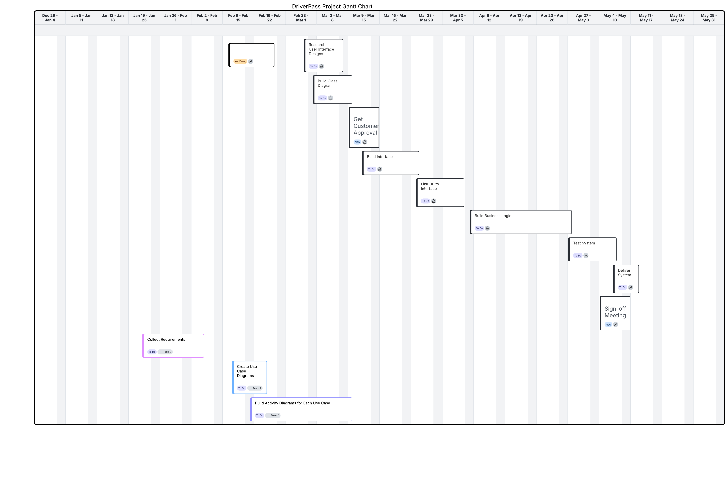
Figure 1. DriverPass Project Gantt Chart created in Lucidchart.

